|  |  |  |
| --- | --- | --- |
| Group | : | Team Miggy |
| Names | : | Castillo, Reneé Dominique M.  Cempron, Jonathan Paul C.  Deogracias, Nolan Matthew T.  Hayakawa, Yuuki V.  Nablo, Juan Paolo J.  Olan, Andrea Michelle M.  Punzalan, Alexander John M.  Tejada, Mima Maiden B.  Torres, Miguel Alfonso C.  Vivo, Roi Emmanuel A. |
| Section | : | S11 |

|  |  |  |  |
| --- | --- | --- | --- |
| **Description**  What’s the problem? | **Cause**  What causes the problem? | **Symptoms**  How do we know the problem exists? | **Impact**  Why is this important? What are the consequences? |
| No proper system in monitoring the Purchasing Orders from both the client and supplier when product deliveries to client are made. | Purchasing Orders from the client and supplier are done and monitored manually via Microsoft Excel. | The manual process of monitoring the Purchasing Orders causes a lengthy and extensive procedure, which takes more time. | Errors may happen anytime. One error can drastically misinterpret the information being sent to the supplier or client. |

**Visualize the process**

Draw a flowchart or simple diagram that illustrates the business process of the client.

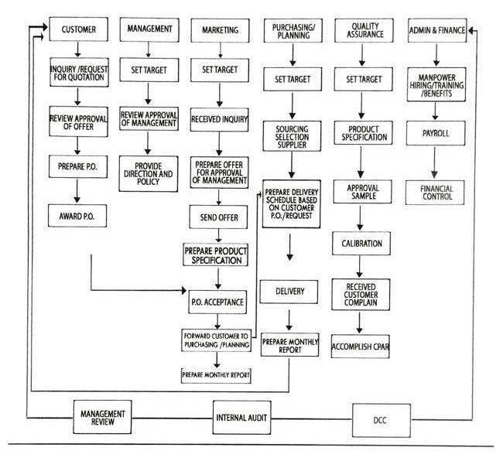

**What is the business goal? Why do they need a computing solution?**

The business goal is to cater the client’s requests and needs by finding the “best” supplier (in terms of price and quality of work) who will produce their products. The company acts as a window or a bridge between the supplier and the client. Since the company relays the information from the client to the supplier (and vice versa), each of them requires a Purchasing Order form per product (PO). The PO contains all the necessary information (such as the number of products needed, specifications, price per item, etc.) for the supplier to understand what is needed to be produced.

A system is needed where it can track and monitor the ongoing deliveries of products from the supplier to the client based on their Purchasing Order forms. This type of solution is needed because all of the monitoring processes are done manually which causes a lengthy procedure. Thus, the procedure takes more time. All the documents are produced as hard copies, meaning that resources such as printing materials are used, rather than just sending all the documents digitally. This also saves the employee’s time and effort in checking and evaluating summary reports.

**What characteristics should the solution have? (Non-functional requirements)**

- Easy-access and real-time update of information such as Purchasing Orders (product price, description, quantity), clients’ and suppliers’ data, standings, etc.

- No difficulties in adding, updating and maintaining data of the system.

- Produce daily/weekly/monthly delivery report that summarizes all the transactions in that certain time period

> Needed documents can be printed using this feature

- Data can be exported into a personal computer, and can be evaluated even without the presence of the server.

- Data is stored in a local database, wherein only the employees in the branch can access it.